Custom Branding

# Will Include

The initial release of custom branding will include

* **Colors** - Customers can choose their two primary colors. Doing so will auto-color everything that is currently teal or orange (icons and links).
* **Company Identity** - Customers can specify their own company name and product name which will be used in all out-going emails and website text.
* **Images** - Customers can replace the header logo (by default the SparkWeave Logo) and the primary background image (currently tiled grey stripes)
* **By-Hand Customization** - Hand-written custom CSS can be used to add any extra styling beyond the above options.
* **Persistance** - The user's create brand will stick around across upgrades to the product. The created brand will be a permanent solution that requires no special steps from support to maintain across upgrades.
* **Experimentation and Rollback** - The admin interface for branding will allow users to save multiple look & feels and will allow the admin to switch between custom brands and the default brand at will.

## Bonus / Optional Items

* **Preview Pane** – It would be nice to have a preview option for stage 1 of branding so that admins can preview the affects of their branding settings before applying them, but this may be skipped in favor of an earlier release.

## Challenges

* All future releases will have to be tested with branding in mind to ensure that any new images added to the product where correctly marked for conversion from their default color to the user-specified color.
* After all upgrades, the image conversion process will have to run over any new or changed images to convert their color – this will have to be done for all saved styles.
* Revised media will have to be distributed throughout the cluster (or at least to all web nodes)

# Will Not Include

There are a variety of items that the first stage of custom branding will not include

* **Text customization** – At this time there are approximately 30 end-user-facing emails sent out by our product that could potentially have their text customized. Until we pare this list down, text customization options may be too overwhelming to the admin. We have not thought through the ramifications that text customization will have on translation/internationalization. Finally, the work behind text customization is completely orthoganal to look & feel branding. If we can release sooner without text customization included, why not do so?
* **Client-side Branding** – stage 1 branding will be for the web interface only. It will not include branding for the clients that communicate with the SparkWeave core (Android, Iphone, or Windows)

# Will Never Include

* **Branding of the admin console** (though this would be a possiblity for OEM branding which is a separate goal). Most products do not touch the look and feel of the admin console after a new user-created brand is applied. The admin console retains the original look of the product, both to retain some product identity and to differentiate the admin portal from the end-user portal.  
    
  In addition, it would be difficult to brand the admin interface because of our multi-colored (orange and teal together) flow-page images. These images could not be automatically color-converted and would present a problem for quick & easy branding efforts.

# Mockups

## List of Available Brands

The currently active brand is starred. A different brand can be activated by clicking on it's star icon or the activate icon under actions.

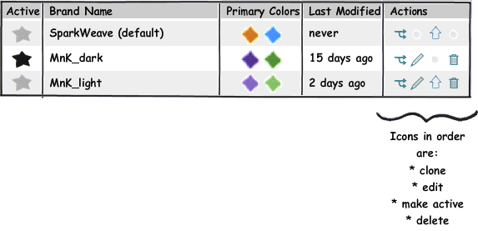

## Creating a Brand

